   



**DAC-2-E-Methane: Realizing Carbon Capture Utilization for Energy Storage & Transportation in North Rhine-Westphalia, Germany**

**Essen/Duisburg/Aachen, 25.06.2024.** Greenlyte Carbon Technologies, the Institute of Energy and Environmental Process Engineering (LEE) of University of Duisburg-Essen, the Hydrogen and Fuel Cell Center (ZBT) and the Chair of Technical Thermodynamics (LTT) of RWTH Aachen University have joined forces to research the coupling of a Direct Air Capture (DAC) plant with a catalytic methane synthesis. The project will showcase a carbon capture utilization case in the heart of the industrial Ruhr area and is co-funded by the European Union and the state of NRW as part of the EFRE "Energie.IN.NRW" innovation competition.

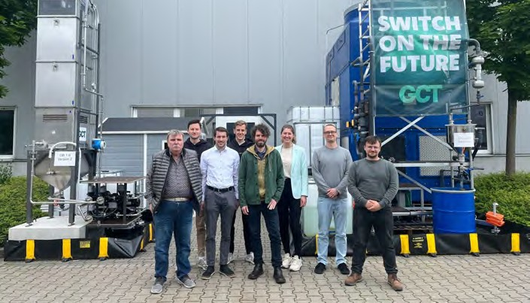

# Background

The expansion of renewable energies is leading to a steady increase in the supply of electrical energy. To store and transport this energy efficiently, it is increasingly being converted to hydrogen (H2). However, H2 has a low energy density at moderate pressure, and the necessary infrastructure yet needs to be built. The DAC-2-E-Methane cooperation project offers an innovative solution for converting large amounts of electrical energy into methane. By converting green H2 and carbon dioxide (CO2) captured from the air into methane, a climate-neutral energy source is produced that can be easily fed into the existing natural gas network. This enables long-term availability and transportability of the stored energy.

1

   



# Project consortium and objectives

Greenlyte Carbon Technologies, the Institute of Energy and Environmental Process Engineering (LEE) of the University of Duisburg-Essen, the Hydrogen and Fuel Cell Center (ZBT) and the Chair of Technical Thermodynamics (LTT) of RWTH Aachen University are working together in this pioneering project. They are jointly exploring the coupling of a disruptive DAC process with catalytic methane synthesis. The collaborative project includes the construction and operation of a demonstrator as well as detailed simulations for operational optimization on process and system level as well as an environmental assessment. The high energy efficiency of Greenlyte's innovative DAC process, which can be operated with renewable energy and a high degree of flexibility, forms the basis of this project.

"Our next R&D step is ambitious as we will further develop our DAC plant within a utilization setup, seamlessly integrating it with catalytic methane synthesis," said **Dr. Niklas**

**Friederichsen**, Chief Technology Officer at Greenlyte Carbon Technologies. "The innovative approach we are taking underscores our commitment to driving forward the energy transition with a practical, high-impact technology. Researching the production and handover of feedstock gases to a methanation reaction in the context of a fluctuating production of renewable energy is a key building block for a systematic technology roll-out."

# Significance of the project for NRW and beyond

DAC-2-E-Methane is a flagship project that is helping to develop NRW into the most modern and climate-friendly industrial location in Europe. It is supported by numerous regional partners from the gas industry as well as their suppliers and customers, and sets standards for the future energy industry.

"DAC-2-E-Methane represents a pivotal advancement in our pursuit of sustainable energy solutions. By capturing CO2 from the air and converting it into methane, we are unlocking a new pathway for energy storage and transportation that leverages the existing natural gas infrastructure," stated **Dr. Timm Kehler**, CEO of Zukunft Gas and holding the patronage of the DAC-2-E-Methane project. "This project exemplifies the innovation and collaboration needed to position NRW as a leader in the climate-friendly energy sector, setting a benchmark for future initiatives across Europe and beyond."

# The role of process and system modeling and environmental assessment

The project lasts three years and includes several work packages addressing the challenges of building a continuously operating and integrated DAC-2-SNG plant. "In DAC-2-E-Methane, we want to use models to optimize the individual process components – the direct air contactor, the CO2 desorption and their system," summarizes **Dr. Friedrich Waag**, research assistant at LEE. "The goal is to minimize the total cost per captured CO2 or produced CH4. The demonstration of economic efficiency also requires the illustration of realistic scenarios to which we can flexibly adapt our models".

2

   



For an optimal use of the DAC-2-SNG plant in combination with an energy system, an integrated system model is developed. “We optimize the operational cost of the integrated system while assessing the environmental impacts using Life Cycle Assessment. The insights gained from the optimization model contribute to a better understanding of the real system”, explains **Prof. Niklas von der Aßen**, Head of LTT.

# The plant will be erected and operational in 2025

For the project, the consortium can make use of an existing methanation plant and a hydrogen electrolyzer at the ZBT site in Duisburg. “With this project funding, ZBT will have the opportunity to strengthen its research and development portfolio in the area of power to gas and sector coupling technologies, building on the successful research work of previous projects. In addition to plant design and integration of process units, ZBT is focusing on optimizing its proprietary methane synthesis. We are pleased to host the demonstrators on our hydrogen test field and to make innovative technology clear and accessible to experts and decision makers in the energy sector” said **Dr. Ulrich Gardemann**, Project Manager at ZBT.

The plant is expected to be installed in early 2025.

# Project Line-up Project Patron

Dr. Timm Kehler, CEO Zukunft Gas

# Consortium partners

Greenlyte Carbon Technologies GmbH | Project Website, Press Kit

Institute of Energy and Environmental Process Engineering (LEE), University of Duisburg-Essen Hydrogen and Fuel Cell Center (ZBT)

Chair of Technical Thermodynamics (LTT**)**, RWTH Aachen University

# Associated partners

Atmosfair, Gelsenwasser, H2UB, Iqony, NRW.Energy4Climate, Uniper, Zukunft Gas

# Contact

Martin Schmickler

Chief of Staff, Greenlyte Carbon Technologies

[ms@greenlyte.tech](mailto:ms@greenlyte.tech)

3